Supplemental Tables
Table S1. CD spectral properties of ferric WT and mutant CPO in phosphate buffer, pH 5.9 in the heme region ((+), (-), (s) indicate positive and negative signals, and a shoulder in a band, respectively).

Protein | δ band (nm) | Soret (nm) | CT band (nm) | Q bands (nm)
WT CPO | 372(-) | 428(--) | 480(-) | 545(++)
R26A CPO | 344(-) | -- | 481(-) | 561(--), 572(--)
N33A CPO | 350(-) | 424(--) (s) | -- | 547(+), 559(-), 579(-)
R26A/N33A CPO | 345(-) | 420(--) (s) | -- | 575(--), 580(--)

Table S2. Spectral properties of ferrous WT, R26A, N33A, and R26A/N33A CPO and their CO complexes.

Protein | δ band (nm) | Soret (nm) | Q band (nm)
WT CPO | -- | 408 | 550
WT-CO | -- | 445 | 550
R26A | -- | 408 | 551
R26A-CO | -- | 444 | 551
N33A | -- | 407 | 551
N33A-CO | 358 | 443 | 551
R26A/N33A | -- | 408 | 550
R26A/N33A-CO | 357 | 444 | 550

Table S3. Extinction coefficients of oxidized ABTS, MCD, hydrogen peroxide, and styrene.

Substrate or product | Wavelength | Extinction  Coefficient (mM⁻¹cm⁻  1)
Oxidized ABTS | 405 nm | 36.8
MCD | 278 nm | 12.2
H2O2 | 240 nm | 0.0436
Styrene | 262 nm | 0.6225

Supplemental Figures
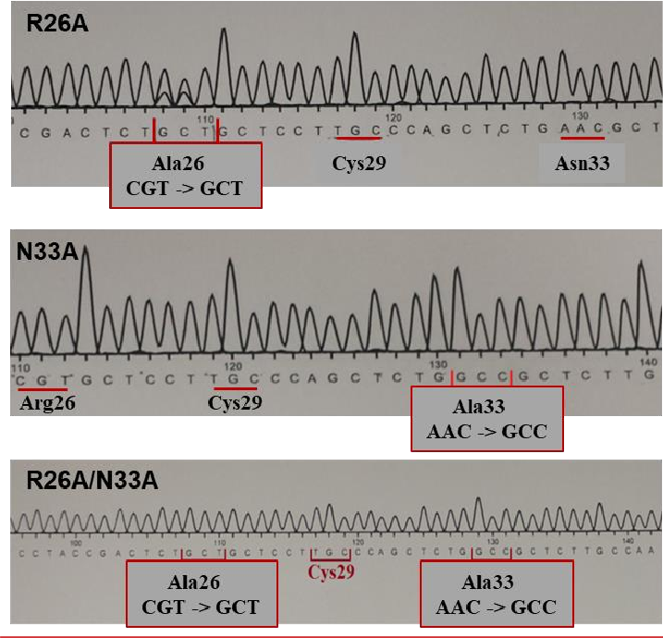
Figure S1. DNA sequencing results showing introduced amino acid substitutions (Arg26 and Asn33 were replaced with Ala).

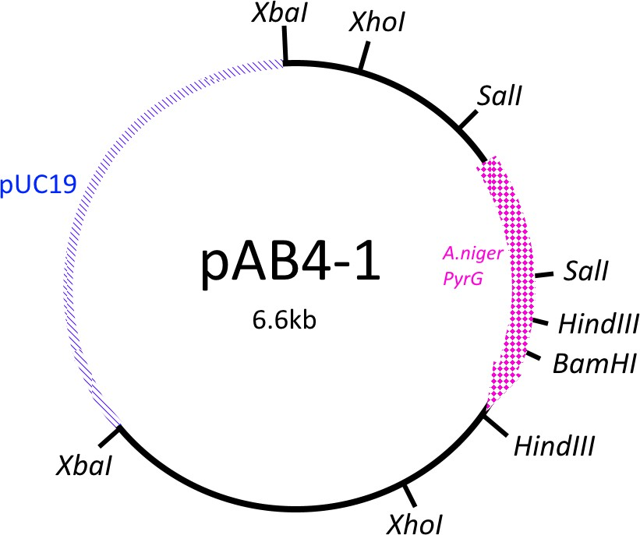

Figure S2. pAB4-1 plasmid containing A. niger PyrG gene as a selection marker allowing fungal growth without uridine supplementation.

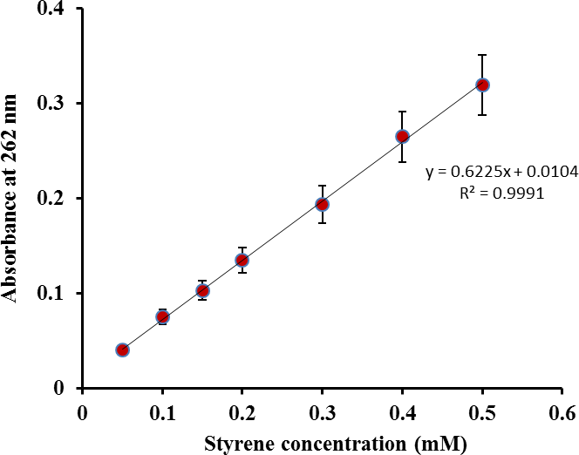

Figure S3. A plot of styrene concentration versus absorbance at 262 nm (n=3). Error bars represent standard deviation.

