Supplemental Figures:

Supplemental Figure 1: Spline regression of immunotherapy usage over time, to account for non-linearity.
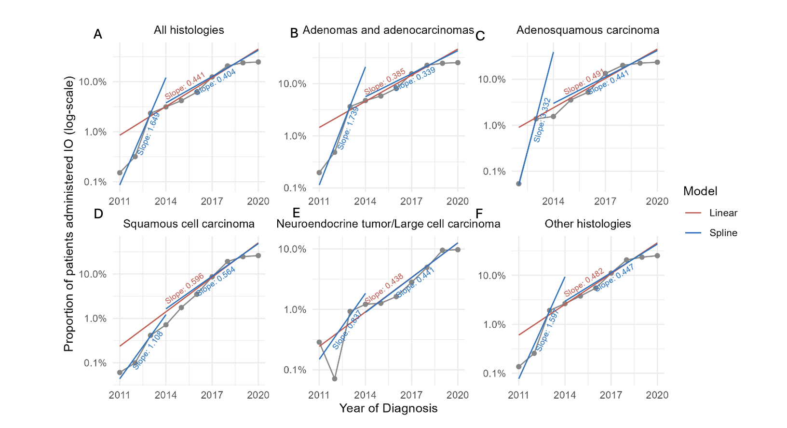

Supplemental Tables

Supp Table 1: Patients included from the NCDB
Numbers included | Exclusions
NSCLC patients diagnosed 2004-2020  n=2,028,553 | • Diagnosed after 2020 (n=122,491)
Analysis (cohort)
Stage  n=1,758,129 | • Clinical stage other than I, II, III, or IV (n=8,561)  • Clinical stage unknown (n=261,863)
Grade  n=1,097,219 | • Grade/differentiation other than 'Well', 'Moderately',  'Poorly', or 'Undifferentiated' (n=6,502)  • Grade/differentiation unknown (n = 924,832)
Surgery  n=596,409 | • Did not receive surgery (n = 1,425,117)  • Surgery status or type unknown (n=7,027)
Systemic treatment  n=1,980,499 | • Systemic treatment status unknown (n=48,054)
Immunotherapy  n=1,265,149 | • Diagnosed before 2011 (n=757,801)  • Immunotherapy status unknown (n=5,603)
Overall Survival  n=1,637,539 | • Diagnosed after 2017 (n=390,702)  • No confirmed date of last contact or death (n=258)

Supp Table 2: Demographics of patients with NSCLC diagnosed between 2004-2020
Characteristic | 2004  N=98,447 | 2008  N=112,495 | 2012  N=118,879 | 2016  N=132,045 | 2020  N=120,539
Age at Diagnosis, Median(IQR) | 69 (60–76) | 69 (61–77) | 69 (61–77) | 69 (62–76) | 70 (63–77)
Sex, n(%)
Male | 53,992 (55) | 59,773 (53) | 61,743 (52) | 67,186 (51) | 60,315 (50)
Female | 44,455 (45) | 52,722 (47) | 57,136 (48) | 64,859 (49) | 60,224 (50)
Race, n(%)
White | 85,591 (87) | 97,018 (86) | 101,123 (85) | 111,639 (85) | 100,712 (84)
Black | 9,843 (10.0) | 11,550 (10) | 13,192 (11) | 14,476 (11) | 13,518 (11)
American Indian, Aleutian, or Eskimo | 184 (0.2) | 254 (0.2) | 318 (0.3) | 387 (0.3) | 440 (0.4)
Asian or Pacific Islander | 1,663 (1.7) | 2,185 (1.9) | 2,921 (2.5) | 3,897 (3.0) | 3,904 (3.2)
Other | 327 (0.3) | 456 (0.4) | 543 (0.5) | 829 (0.6) | 1,103 (0.9)
Unknown | 839 (0.9) | 1,032 (0.9) | 782 (0.7) | 817 (0.6) | 862 (0.7)
Ethnicity, n(%)
Non-Spanish, non-Hispanic | 86,309 (88) | 99,802 (89) | 111,333 (94) | 124,943 (95) | 114,175 (95)
Spanish, Hispanic | 2,320 (2.4) | 3,021 (2.7) | 3,495 (2.9) | 4,309 (3.3) | 4,249 (3.5)
Unknown | 9,818 (10.0) | 9,672 (8.6) | 4,051 (3.4) | 2,793 (2.1) | 2,115 (1.8)
Insurance status, n(%)
Uninsured | 2,831 (2.9) | 3,278 (2.9) | 4,163 (3.5) | 2,632 (2.0) | 2,272 (1.9)
Private | 28,887 (29) | 32,373 (29) | 30,419 (26) | 31,667 (24) | 25,896 (21)
Medicaid | 4,704 (4.8) | 6,210 (5.5) | 7,352 (6.2) | 9,455 (7.2) | 9,248 (7.7)
Medicare | 57,814 (59) | 66,863 (59) | 72,752 (61) | 83,935 (64) | 78,884 (65)
Other Government | 1,078 (1.1) | 1,601 (1.4) | 1,964 (1.7) | 2,713 (2.1) | 2,972 (2.5)
Unknown | 3,133 (3.2) | 2,170 (1.9) | 2,229 (1.9) | 1,643 (1.2) | 1,267 (1.1)
Charlson-Deyo Score, n(%)
0 | 61,929 (63) | 65,711 (58) | 67,478 (57) | 78,032 (59) | 68,769 (57)
1 | 26,012 (26) | 31,279 (28) | 34,020 (29) | 30,623 (23) | 27,842 (23)
2 | 8,052 (8.2) | 11,071 (9.8) | 12,433 (10) | 13,468 (10) | 12,558 (10)
>=3 | 2,454 (2.5) | 4,434 (3.9) | 4,948 (4.2) | 9,922 (7.5) | 11,370 (9.4)

Supp Table 3: Logistic regression results of being diagnosed with Stage I NSCLC on the year of diagnosis
HIstology | N | OR (95% CI) | p-value
All | 1,758,129 | 1.05 (1.05-1.05) | <0.001
Adenocarcinoma | 909,473 | 1.03 (1.03-1.04) | <0.001
Adenosquamous | 23,569 | 1.00 (0.99-1.00) | 0.52
Squamous | 493,039 | 1.02 (1.02-1.02) | <0.001
Neuroendocrine | 77,705 | 1.12 (1.11-1.12) | <0.001
Other | 254,343 | 1.12 (1.11-1.12) | <0.001

Supp Table 4: Logistic regression results of being diagnosed with well-differentiated grade on the year of diagnosis
HIstology | N | OR (95% CI) | p-value
All | 1,097,219 | 1.04 (1.04 to 1.04) | <0.001
Adenocarcinoma | 544,629 | 1.01 (1.01 to 1.01) | <0.001
Adenosquamous | 18,026 | 1.00 (0.98 to 1.03) | 0.77
Squamous | 342,841 | 0.99 (0.99 to 0.99) | <0.001
Neuroendocrine | 54,731 | 1.18 (1.18 to 1.19) | <0.001
Other | 136,992 | 1.09 (1.08 to 1.10) | <0.001

Supp Table 5: Logistic regression results of receiving chemotherapy based on year of diagnosis
HIstology | N | OR (95% CI) | p-value
All | 1,980,499 | 0.98 (0.98-0.98) | <0.001
Adenocarcinoma | 1,006,968 | 0.98 (0.98- 0.99) | <0.001
Adenosquamous | 26,851 | 1.00 (1.00-1.01) | 0.78
Squamous | 545,637 | 0.99 (0.99-0.99) | <0.001
Neuroendocrine | 99,688 | 0.95 (0.95-0.95) | <0.001
Other | 301,355 | 0.96 (0.96-0.96) | <0.001

Supp Table 6: Logistic regression results of receiving immunotherapy based on year of diagnosis
HIstology | N | OR (95% CI) | p-value
All | 1,265,149 | 1.55 (1.55-1.56) | <0.001
Adenocarcinoma | 698,252 | 1.47 (1.46-1.47) | <0.001
Adenosquamous | 17,064 | 1.63 (1.59-1.68) | <0.001
Squamous | 357,660 | 1.81 (1.80-1.83) | <0.001
Neuroendocrine | 57,228 | 1.55 (1.51-1.59) | <0.001
Other | 134,945 | 1.62 (1.60-1.63) | <0.001

Supp Table 7: Logistic regression results of receiving a pneumonectomy based on year of diagnosis
HIstology | N | OR (95% CI) | p-value
All | 596,409 | 0.90 (0.90-0.91) | <0.001
Adenocarcinoma | 326,144 | 0.90 (0.90-0.90) | <0.001
Adenosquamous | 13,261 | 0.91 (0.90-0.92) | <0.001
Squamous | 153,554 | 0.91 (0.91-0.91) | <0.001
Neuroendocrine | 45,875 | 0.91 (0.91-0.92) | <0.001
Other | 57,575 | 0.91 (0.90-0.91) | <0.001

Supp Table 8: Cox regression of overall survival on year of diagnosis by histology (2004-2017)
HIstology | N | Event N | HR (95% CI) | p-value
All | 1,637,593 | 1,330,083 | 0.972 (0.971-0.972) | <0.001
Adenocarcinoma | 796,303 | 627,043 | 0.978 (0.978-0.979) | <0.001
Adenosquamous | 23,126 | 18,861 | 1.007 (1.004-1.011) | <0.001
Squamous | 449,152 | 381,579 | 0.986 (0.985-0.987) | <0.001
Neuroendocrine | 85,240 | 55,675 | 0.952 (0.950-0.954) | <0.001
Other | 283,772 | 246,925 | 0.952 (0.952-0.953) | <0.001

