Supplemental INFORMATION

Title: Lineage-Specific Disruption of Hematopoiesis by Oxaliplatin: Mechanisms of Erythropoietin Resistance and Immune Suppression

Leland C. Sudlow^{a*}, Junwei Du^{a,b*}, Kiana Shahverdiª, Haiying Zhouª, Mikhail Y. Berezin^{a,b}
Institutional Affiliations: ªMallinckrodt Institute of Radiology, Washington University School of Medicine St. Louis, MO 63110, USA; ^{b}Institute of Materials Science & Engineering Washington University, St. Louis, MO 63130, USA

FIGURES
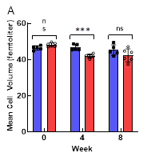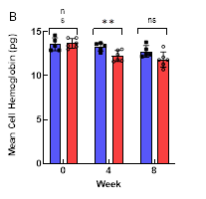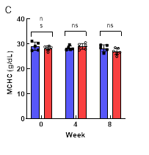
Figure S1 Effects of oxaliplatin on mouse erythrocyte parameters. A). Erythrocyte mean cell volume (fL). B). Erythrocyte mean cell hemoglobin (pg). C) Erythrocyte mean cell hemoglobin concentration (g/dL). Bars represent the average ± STD with individual data points. T-test results are indicated by brackets. Statistical significance marks: *=p<0.05, **=p<0.01, *** = p<0.001, **** = p<0.0001

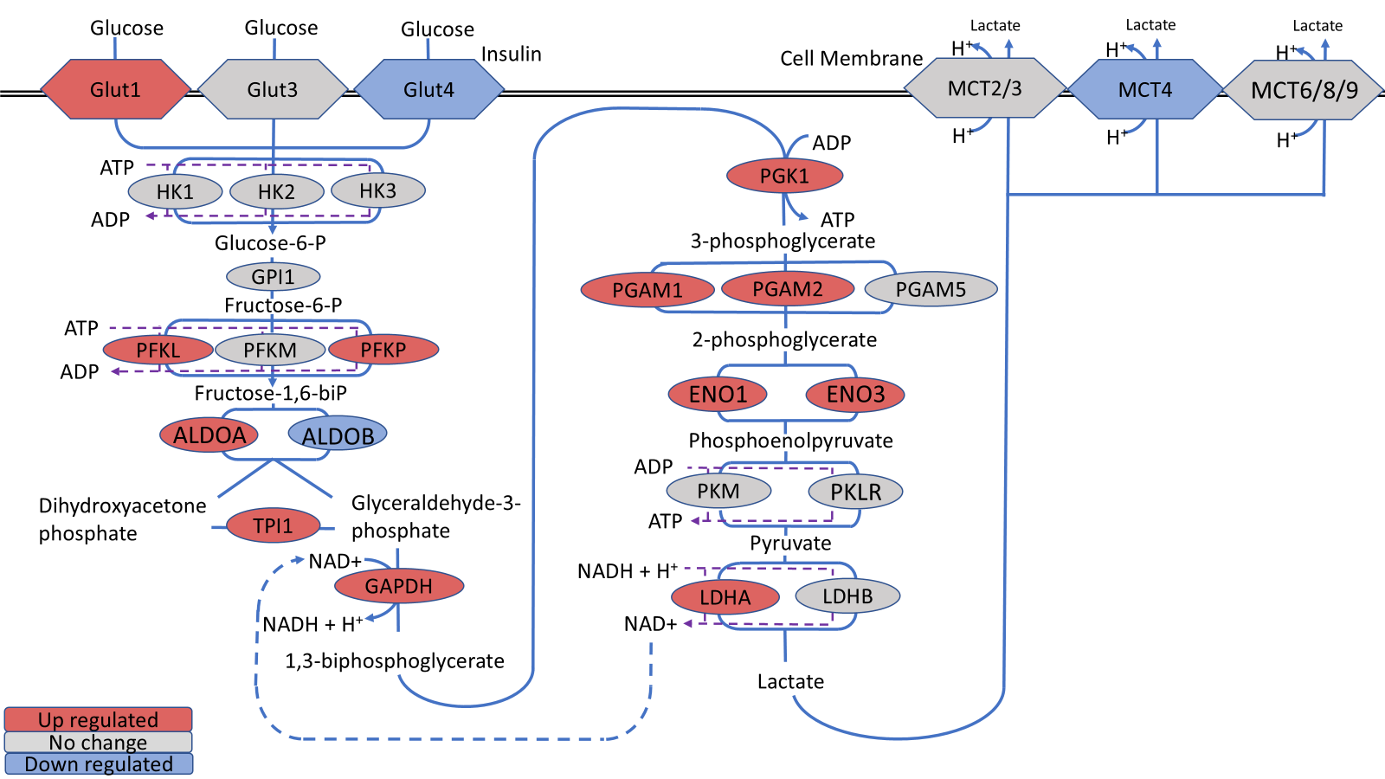
Figure S2: Glycolysis in bone marrow is upregulated in the oxaliplatin treated mice. Abbreviations of enzymes and proteins with encoded genes is in parenthesis: ALDOA, aldolase A (Aldoa); ALDOB, aldolase B (Aldob); ENO1/3, enolase 1and 3 (Eno1and Eno3); GAPDH, glyceraldehyde-3-phosphate dehydrogenase (Gapdh); GLUT1, glucose transporter 1 (Slc2a1); GLUT3, glucose transporter 3 (Slc2a3); GLUT4, insulin-responsive glucose transporter 4; GPI1, glucose-6-phosphate isomerase 1 (Gpi1); HK1/2/3, hexokinase 1/2/3 (Hk1, Hk2, Hk3); LDHA, lactose dehydrogenase A (Ldha); LDHB, lactose dehydrogenase B (Ldhb); MCT1/3/6 monocarboxylic acid transporters 1/3/6 (Slc16a1, Slc16a3, Slc16a6); PGAM1/2/5, phosphoglycerate mutase 1/2/5 (Pgam1, Pgam2, Pgam5); PGK1, Phosphoglycerate Kinase 1 (Pgk1); PKFL, phosphofructokinase liver type (Pfkl); PKFM, phosphofructokinase muscle type (Pfkm); PKFP, phosphofructokinase platelet type (Pfkp); PKLR, pyruvate kinase, liver and RBC (Pklr); PKM, pyruvate kinase, muscle type (Pkm); TPI1, topoisomerase 1 (Tpi1). The schematics is in part based on KEGG Pathways. Red – upregulated genes, grey – unaffected genes, blue downregulated genes.

TABLES
Table S1 Differentially expressed genes from bone marrow: oxaliplatin vs control.
- (see a separate supplemental Excel file named Table S1 Bone marrow 3691 DEGs FC 1.5)

Table S2 Keyword-Based Grouping of GO Terms into Biological Themes
Theme | Keywords
Stress & Cytokine Response | stress, interferon, cytokine, inflammatory, defense
Inflammation & Immune Signaling | inflammation, inflammatory, tnf, il-1, il-6, nf-kb, toll-like, interleukin, chemokine, ccl, cxcl, immune response, inflammasome, pattern recognition, pathogen response
Oxidative Stress & Redox Regulation | oxidative, redox, reactive oxygen, ros, nitrosative, nrf2, antioxidant, glutathione, superoxide, peroxidase, peroxiredoxin, sod, catalase, thioredoxin, oxidoreductase, hydrogen peroxide, peroxide, nitric oxide, peroxynitrite, nadph oxidase, mitochondrial ros, electron transport chain, mitochondrial dysfunction, oxidative damage, protein oxidation, lipid peroxidation, dna oxidation, redox imbalance
Extracellular Matrix & Adhesion | extracellular, matrix, adhesion, integrin, collagen, remodeling, fibronectin, laminin, basement membrane, mmp, matrix metalloproteinase, tenascin, focal adhesion, ecm, tissue remodeling, stromal, scaffold, matrisome, cell junction, cell adhesion, cell-matrix, desmosome
Metabolic Re-wiring | metabolic, oxidoreductase, catabolic, fatty, one-carbon, biosynthetic
Hematopoietic & Immune Commitment | hematopoiet, myeloid, lymphoid, leukocyte, granulocyte, erythro, megakary, erythropoiet, myelopoiet, thrombopoiet, lymphocyte, monocyte, neutrophil, eosinophil, basophil, platelet, erythrocyte, anemia, cytopenia, pancytopenia, thrombocytopenia, leukopenia, neutropenia, immune cell, blood cell, hematologic, hematopoiesis, stem cell, hsc
Cell-Cycle & Apoptosis | cell cycle, mitotic, chromosome, checkpoint, dna replication, nuclear division, apoptosis, programmed cell death, caspase
Neurotrophic Signaling & Growth Factors | neurotrophin, ngf, bdnf, ntf, trk, trka, trkb, gdnf, growth factor, igf, egf, fgf, receptor tyrosine kinase
Immune–Neuronal Crosstalk | microglia, macrophage, satellite glia, neuroimmune, neuroinflammation, cd11b, cd68, csf1, tslp, complement, ccr, cxcr
Pain & Nociception | pain, nociception, nociceptor, hyperalgesia, allodynia, trpv1, trpa1, scn9a, piezo, itch, sensory perception, neuropeptide
Oxidative Phosphorylation & Mitochondria | mitochondrial, oxidative phosphorylation, electron transport chain, atp synthase, complex I, respiratory chain, mitophagy
Autophagy & Proteostasis | autophagy, lysosome, proteasome, ubiquitin, protein folding, chaperone
Bone Remodeling & Osteogenesis | osteogenesis, bone formation, bone development, skeletal development, ossification, mineralization, bone mineralization, osteoblast, osteoblast differentiation, osteoblast proliferation, osteoid, bone matrix formation, alkaline phosphatase, runx2, osterix, sp7, collagen, osteoclast, osteoclast differentiation, osteoclastogenesis, bone resorption, trap, cathepsin k, bone remodeling, bone turnover, skeletal homeostasis, rank, rankl, opg, wnt signaling, beta-catenin, bmp, tgf beta, smad signaling, endosteal niche, bone marrow niche, osteolineage cell, hematopoietic niche, mesenchymal stem cell, stromal cell, bone matrix, hydroxyapatite, osteocalcin, osteopontin, sclerostin, osteoporosis, osteopenia, bone loss
Neuronal Excitability & Synapse (disabled) | axon, dendrite, synapse, neurotransmitter, vesicle, action potential, ion channel, potassium, sodium, calcium, glutamate, gaba, synaptic, neurogenesis, axonogenesis
Myelination & Schwann Cell Biology (disabled) | myelin, schwann cell, mbp, mpz, prx, pmp22, node of ranvier, myelination, myelin sheath, axon ensheathment, remyelination, demyelination, schwann cell differentiation, schwann cell proliferation, schwann cell migration, axon guidance, nerve regeneration
Fibrosis (disabled) | fibrosis, fibrotic, extracellular matrix, matrix organization, matrix remodeling, collagen, fibronectin, laminin, myofibroblast, tissue remodeling, tgf beta, smad signaling, emt, endmt
Adipose Tissue Development (disabled) | adipose tissue, adipogenesis, adipocyte, lipid storage, lipogenesis, ppar gamma, c/ebp, thermogenesis
Cardiac & Muscle Function (disabled) | heart, cardiac, cardiomyocyte, contraction, sarcomere, troponin, myosin, arrhythmia, heart failure, cardiomyopathy

Table S3 Correlation: Erythroid Maturation vs Hemoglobin Genes
 | Hba-a1 | Hba-a2 | Hbb-bt | Hbb-bs
Spta1 | 0.969 | 0.965 | 0.965 | 0.972
Slc4a1 | 0.985 | 0.982 | 0.982 | 0.987
Sptb | 0.965 | 0.959 | 0.958 | 0.967
Ank1 | 0.948 | 0.942 | 0.943 | 0.950
Alas2 | 0.999 | 0.998 | 0.996 | 0.999

Table S4 T cell (CD4) and B cell Marker Correlation
 | T cells | B cells |  |  |  |  |  |  | NK cells | Monocytes
Genes | Cd4 | Cd79a | Cd79b | Ms4a1 | Pax5 | Ighd | Ighm | Il7r | Klrb1c | Irf8
Cd4 | 1.000 | 0.833 | 0.858 | 0.791 | 0.816 | 0.777 | 0.815 | 0.829 | 0.670 | 0.935
Cd79a | 0.833 | 1.000 | 0.988 | 0.961 | 0.978 | 0.897 | 0.962 | 0.984 | 0.725 | 0.930
Cd79b | 0.858 | 0.988 | 1.000 | 0.940 | 0.955 | 0.878 | 0.976 | 0.977 | 0.806 | 0.913
Ms4a1 | 0.791 | 0.961 | 0.940 | 1.000 | 0.916 | 0.973 | 0.916 | 0.942 | 0.679 | 0.914
Pax5 | 0.816 | 0.978 | 0.955 | 0.916 | 1.000 | 0.861 | 0.957 | 0.982 | 0.616 | 0.929
Klrb1c | 0.670 | 0.725 | 0.806 | 0.679 | 0.616 | 0.611 | 0.738 | 0.712 | 1.000 | 0.595
Irf8 | 0.935 | 0.930 | 0.913 | 0.914 | 0.929 | 0.893 | 0.889 | 0.925 | 0.595 | 1.000
Ighd | 0.777 | 0.897 | 0.878 | 0.973 | 0.861 | 1.000 | 0.870 | 0.905 | 0.611 | 0.893
Ighm | 0.815 | 0.962 | 0.976 | 0.916 | 0.957 | 0.870 | 1.000 | 0.965 | 0.738 | 0.889
Il7r | 0.829 | 0.984 | 0.977 | 0.942 | 0.982 | 0.905 | 0.965 | 1.000 | 0.712 | 0.925

